**Unit Testing Documentation**

Contents

Unit Test Scenarios 1

TFL - Buses CC Team 2

TFL - Underground CC Team 4

Customer Service Manager Process 6

TFL – Confidential Case Team 12

TFL – Escalation Team 13

# Unit Test Scenarios

TFL - Buses CC Team

* View Cases assigned to TFL - Buses CC Team - passed
* View logged in user cases - passed
* Should not be able to view cases other than his call centre team - passed
* Create Contact and add notes attachments - passed
* Create Cases and add notes attachments - passed
  + Update Case Type and Case Classification in New Request stage - passed
* Move to "Resolve/Follow Up" stage case should be assigned to "TFL - Customer Service Manager" team - passed

TFL - Underground CC Team

* View Cases assigned to TFL - Underground CC Team - passed
* View logged in user cases - passed
* Should not be able to view cases other than his call centre team - passed
* Create Contact and add notes attachments - passed
* Create Cases and add notes attachments - passed
  + Update Case Type and Case Classification in New Request stage - passed
* Move to "Resolve/Follow Up" stage case should be assigned to "TFL - Customer Service Manager" team - passed

Customer Service Manager Process

* View cases assigned to customer service manager - passed
* Resolve Case button should be visible - passed
* Create Follow up button to be editable on bpf stage - passed
* Resolve the case , bpf to change to resolved and case inactive - passed
* Create Follow up button should give pop-up - passed
* On click of yes follow up request to created to confidential team if case classification is confidential and notes to attached from case and contact(create follow up button will be locked) - passed
* On click of yes follow up request to created to escalation team if case classification is normal and notes to attached from case and contact(create follow up button will be locked) - passed
* Case to automatically move to "Follow up" stage if follow up request is created and follow up date and follow up days to be shown in stage - passed
* Post Completion of follow up, manager can resolve the case and bpf gets resolved and case is closed - passed

TFL – Confidential Case Team

* View Follow up requests assigned to the team in the dashboard - passed
* Should be able to see the attachments in the follow up requests - passed
* Should be able to provide additional info/comments or resolution comments - passed

TFL – Escalation Team

* View Follow up requests assigned to the team in the dashboard - passed
* Should be able to see the attachments in the follow up requests - passed
* Should be able to provide additional info/comments or resolution comments - passed

## TFL - Buses CC Team

Dashboard View Cases assigned to TFL - Buses CC Team, my active cases and cases assigned to team members. Not able to view cases which are with other call centres or outside of BU

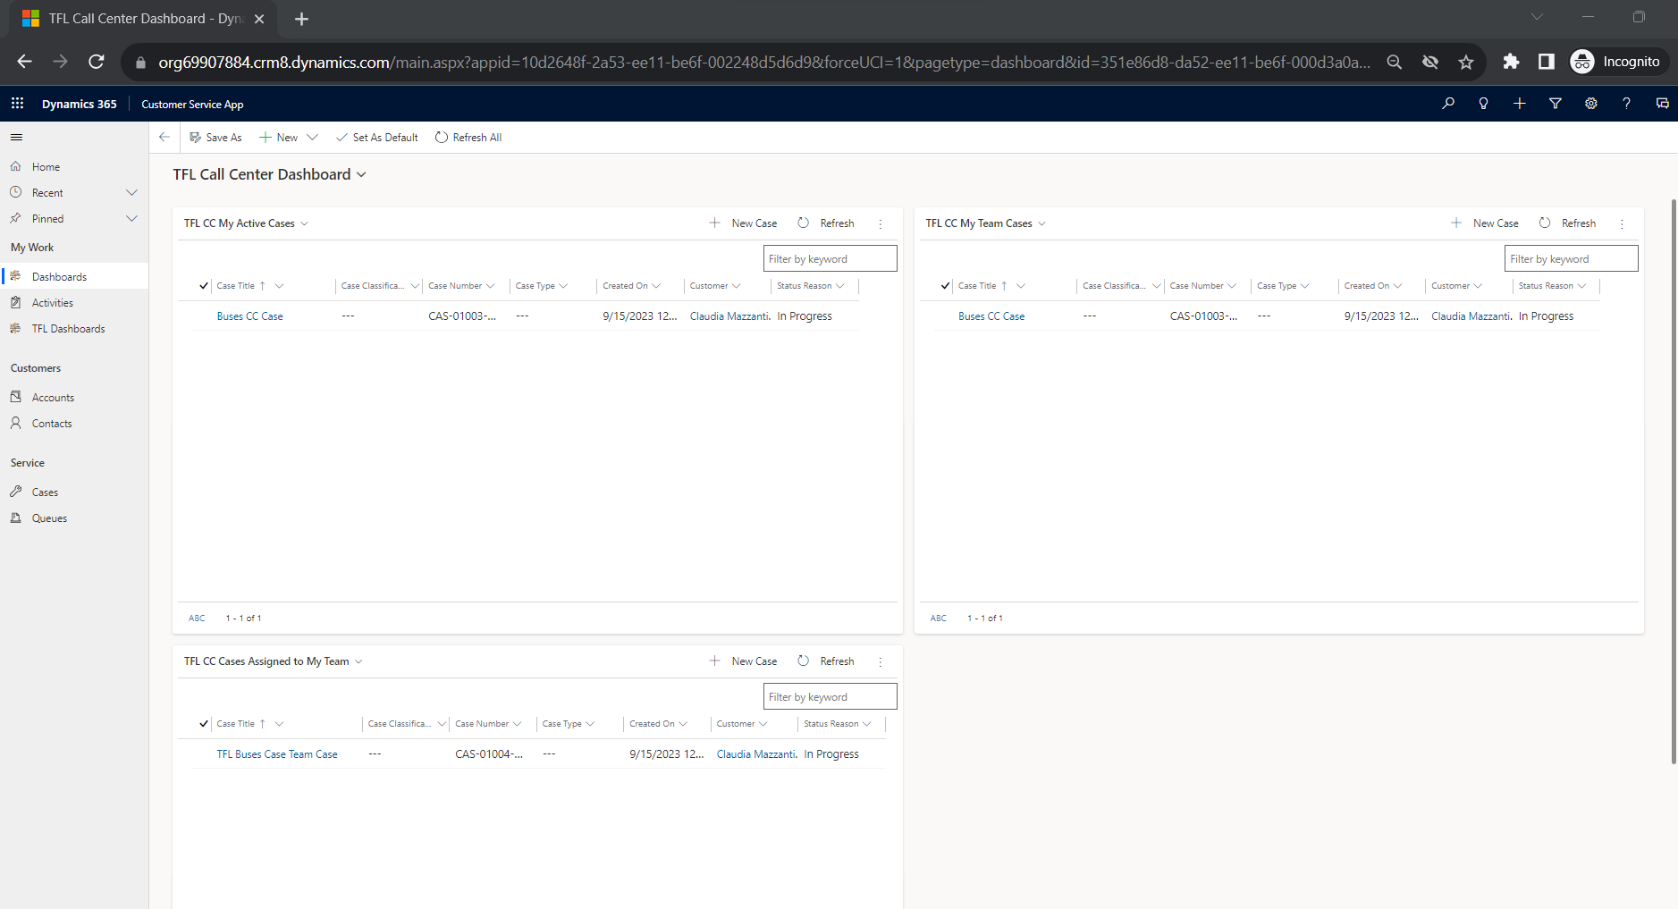

Create Contact and add notes attachments

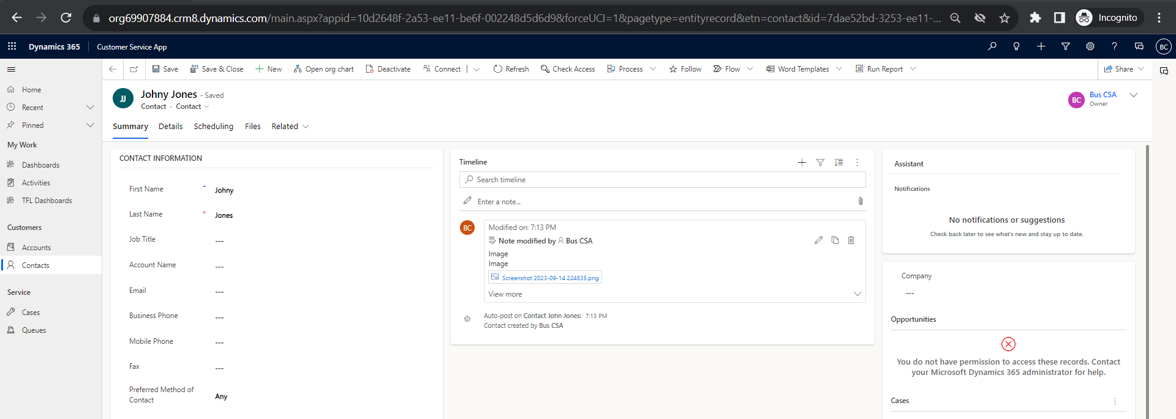

Create Cases and add notes attachments

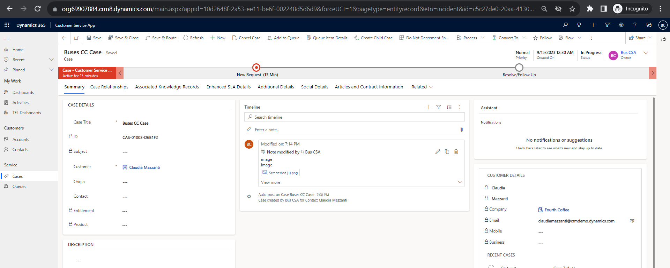

Update Case Type and Case Classification in New Request stage

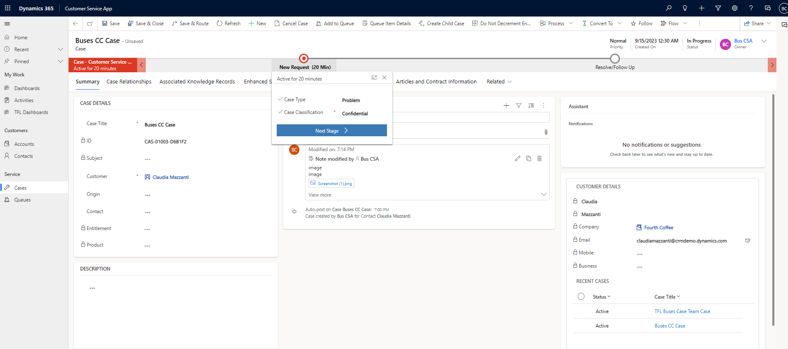

Move to "Resolve/Follow Up" stage case should be assigned to "TFL - Customer Service Manager" team

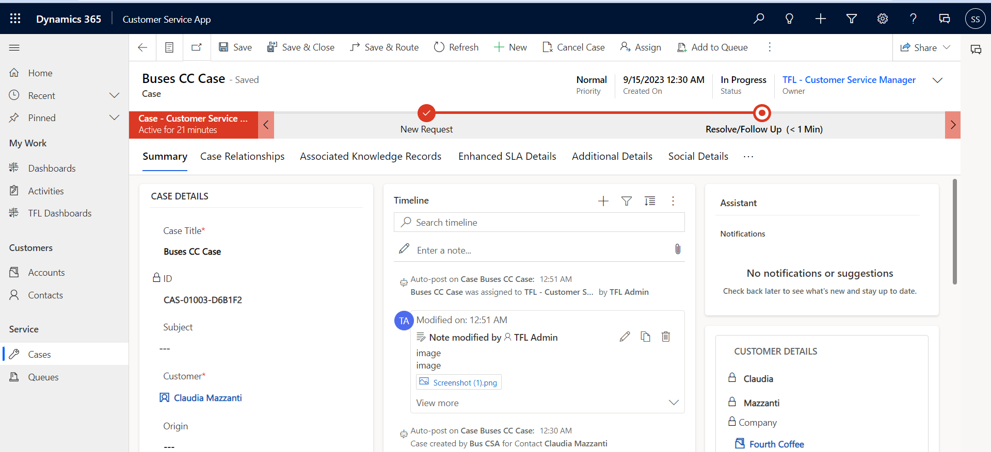

## TFL - Underground CC Team

Dashboard View Cases assigned to TFL - Buses CC Team, my active cases and cases assigned to team members. Not able to view cases which are with other call centres or outside of BU.

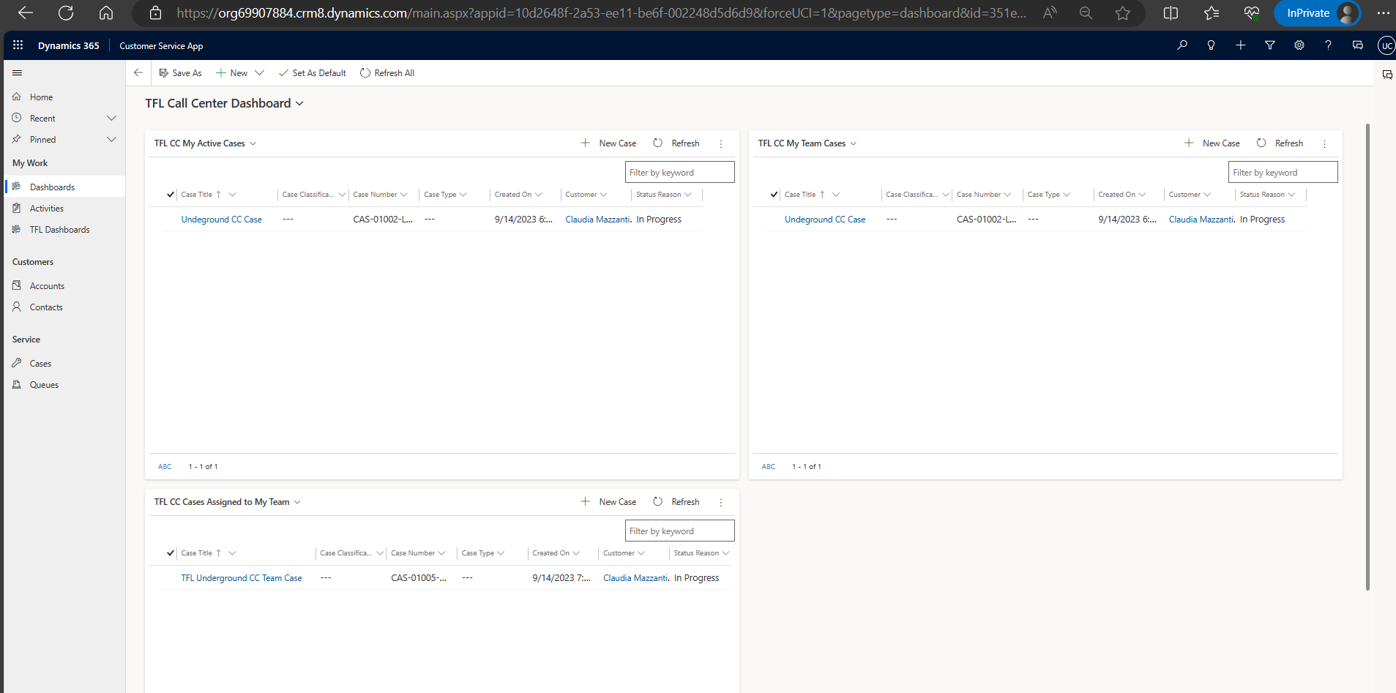

Create Contact and add notes attachments

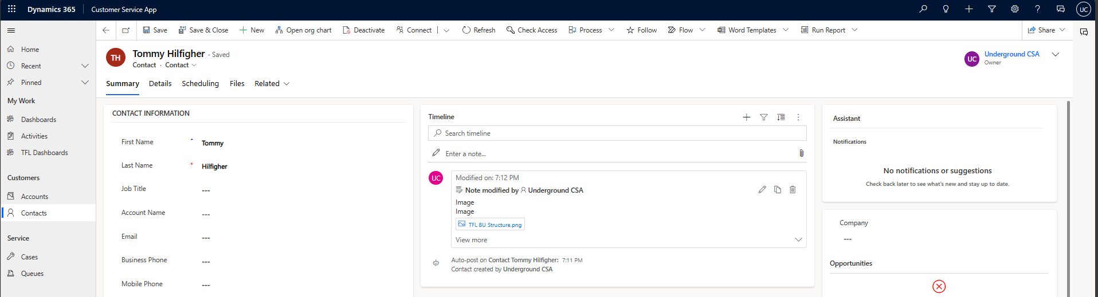

Create Cases and add notes attachments

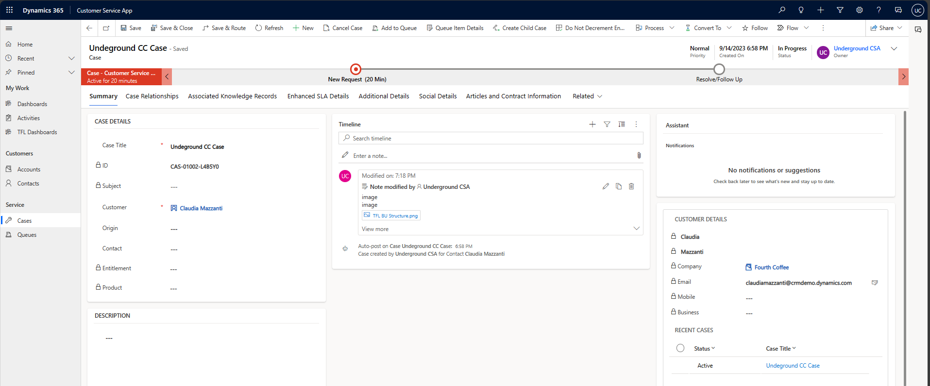

Update Case Type and Case Classification in New Request stage

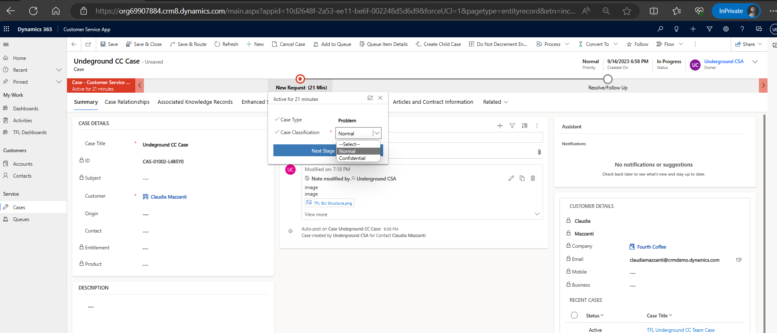

Move to "Resolve/Follow Up" stage case should be assigned to "TFL - Customer Service Manager" team

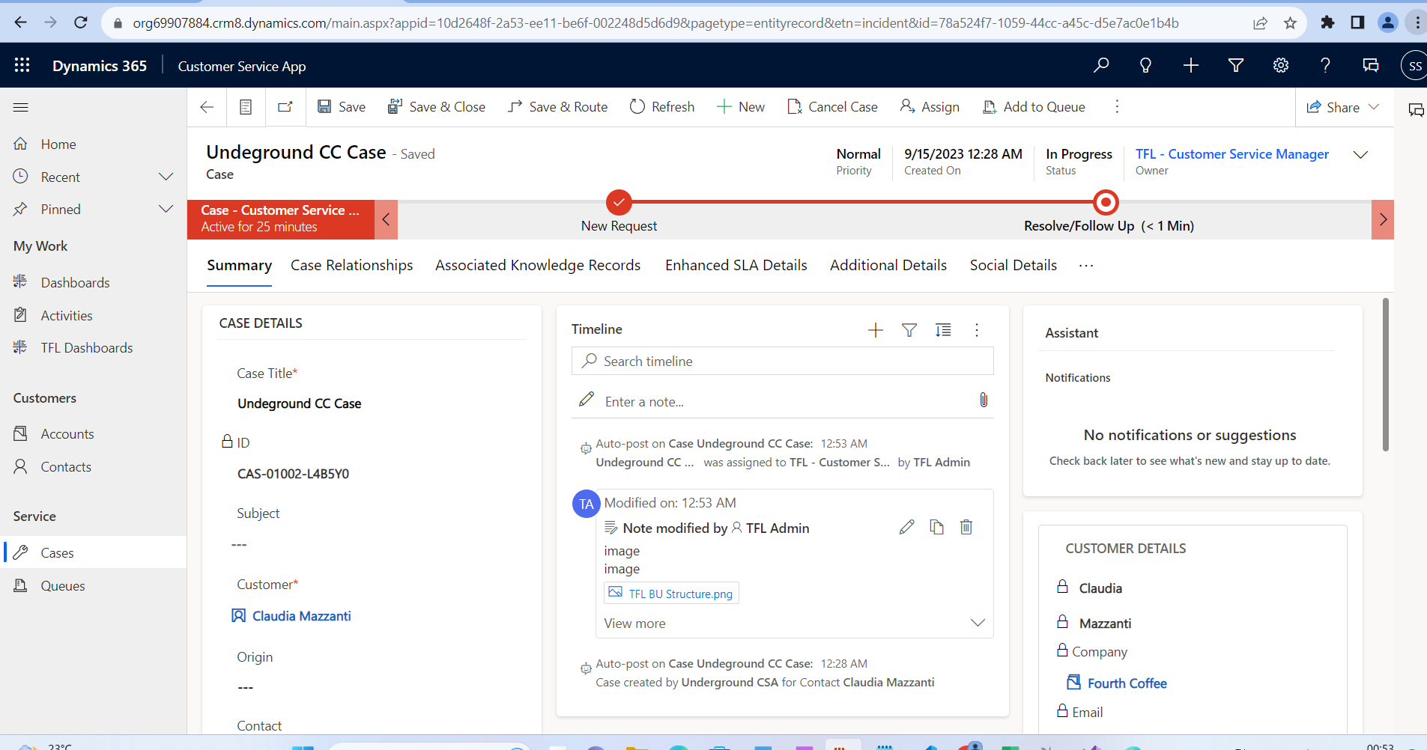

Fields are locked in next stage, below screenshots from admin

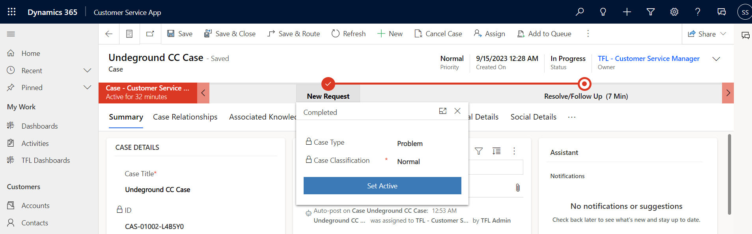

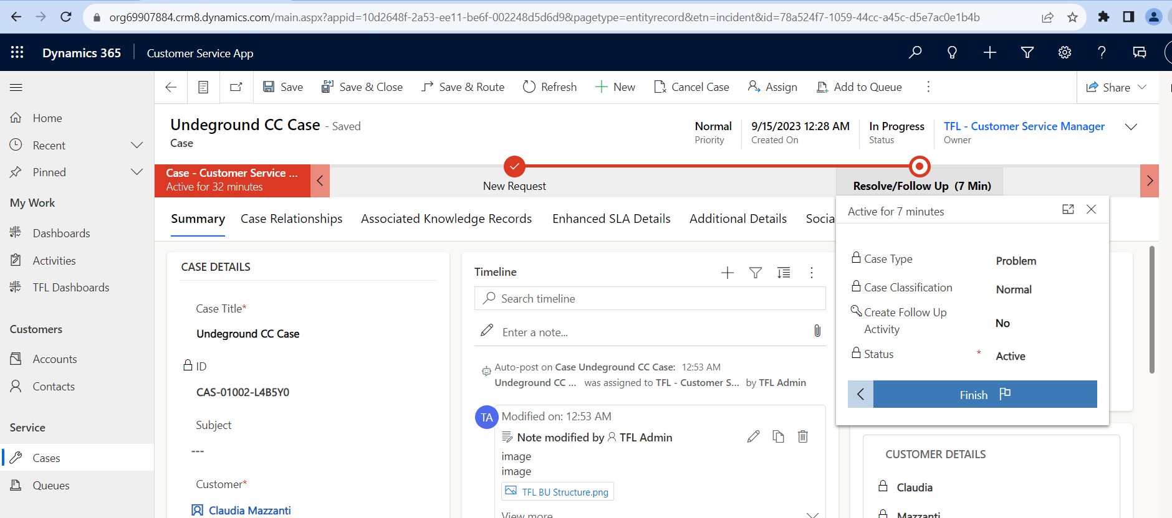

## Customer Service Manager Process

View cases assigned to customer service manager

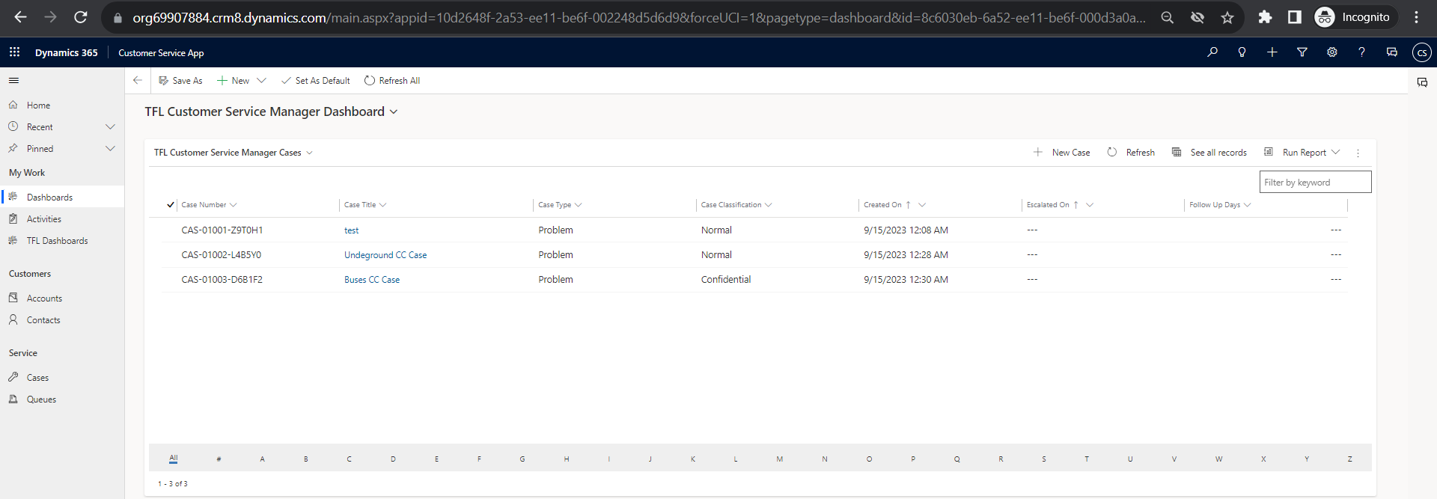

Resolve Case button should be visible

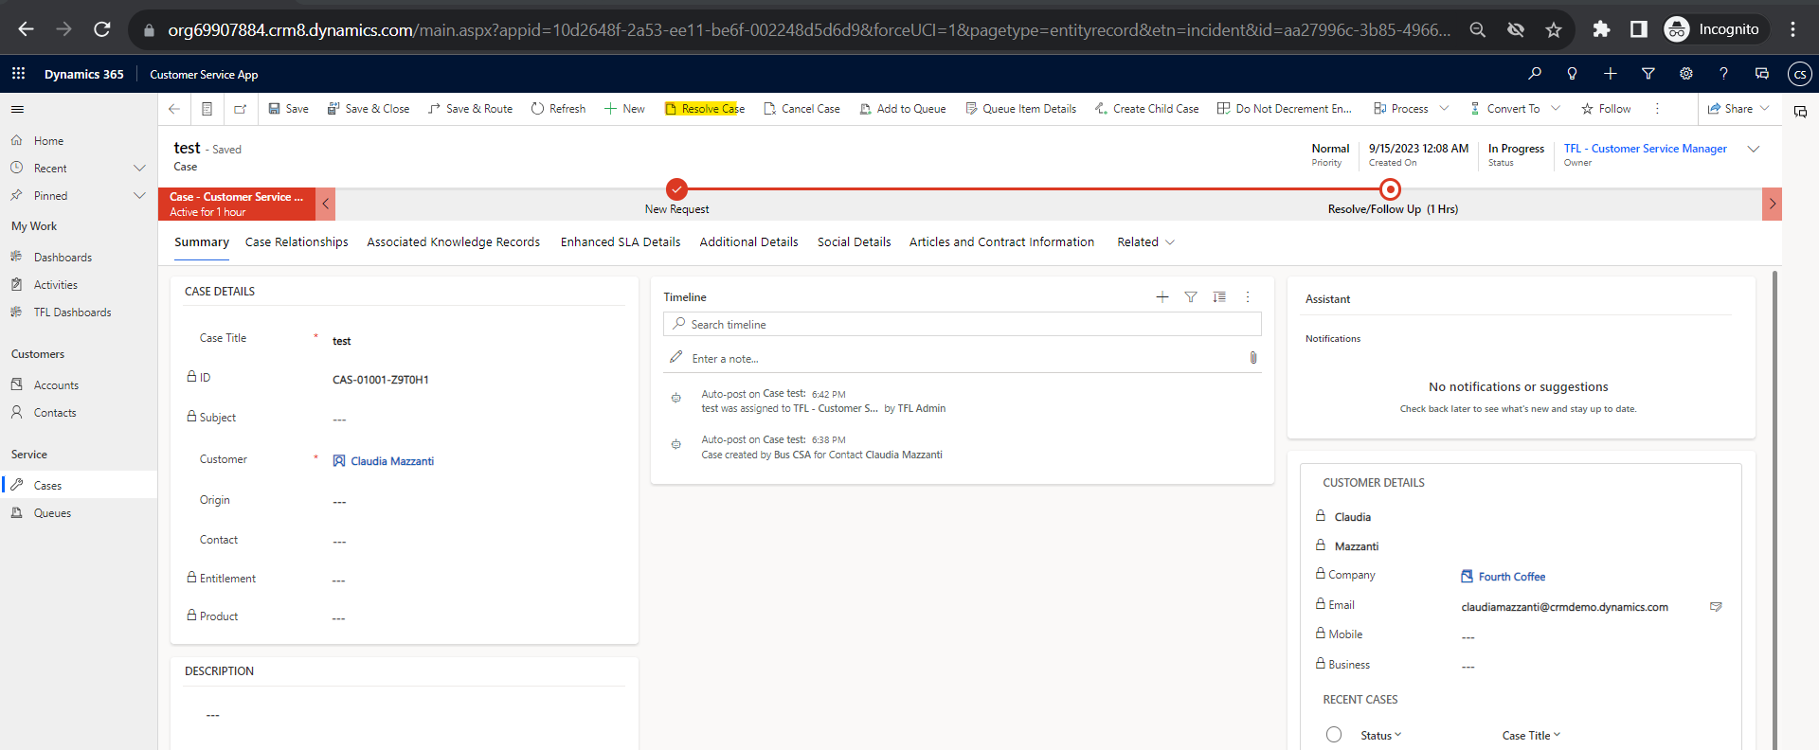

Create Follow up button to be editable on bpf stage

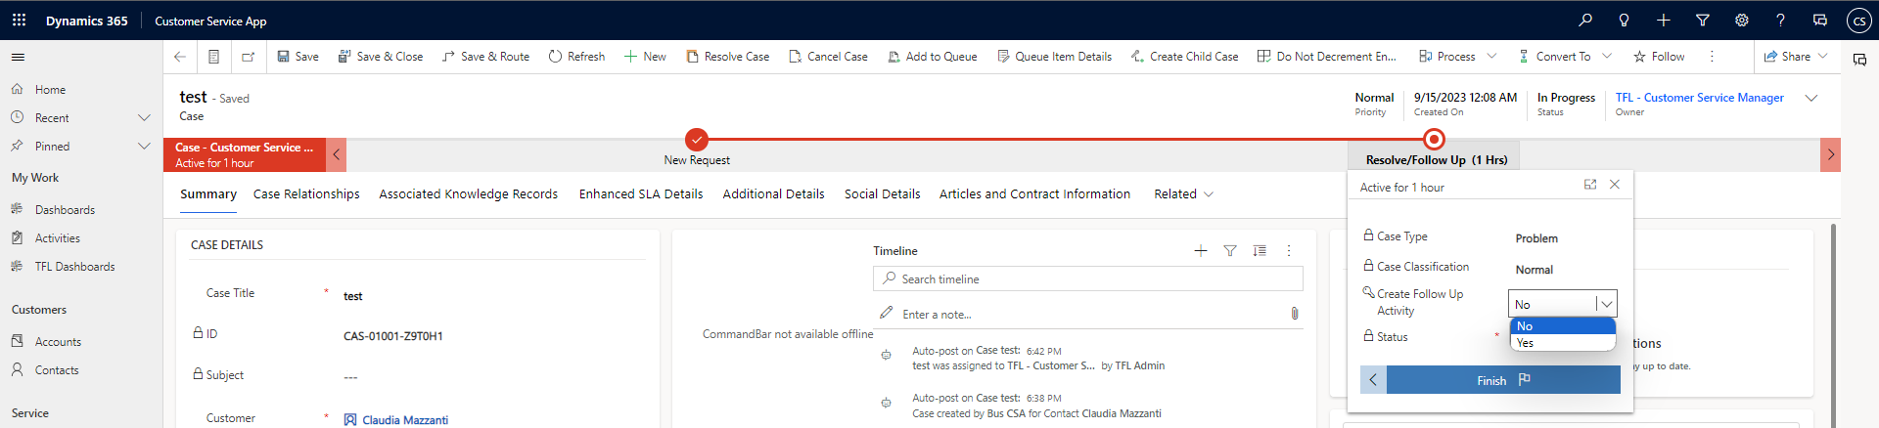

Create Follow up button should give pop-up

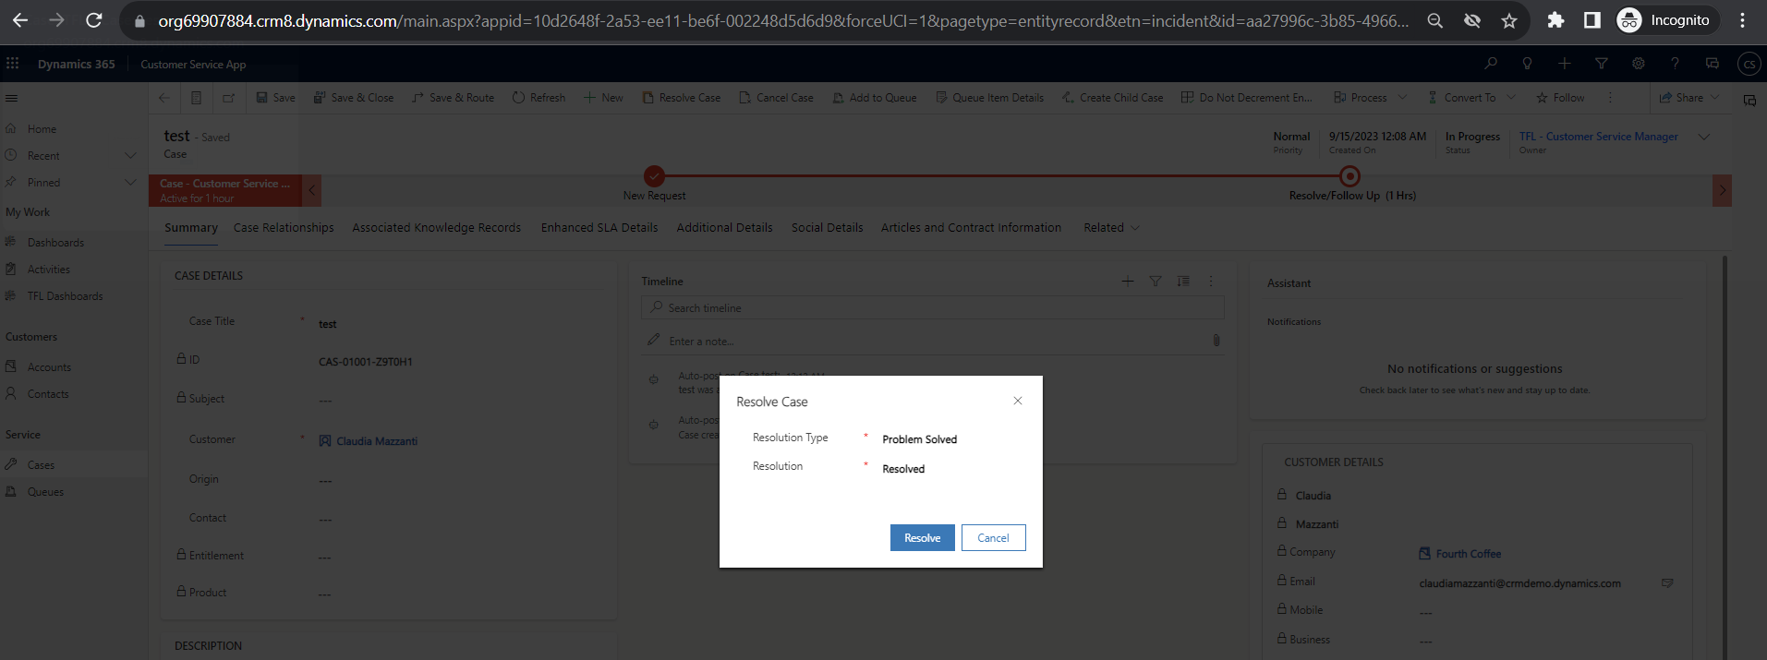

Resolve the case , bpf to change to resolved and case inactive

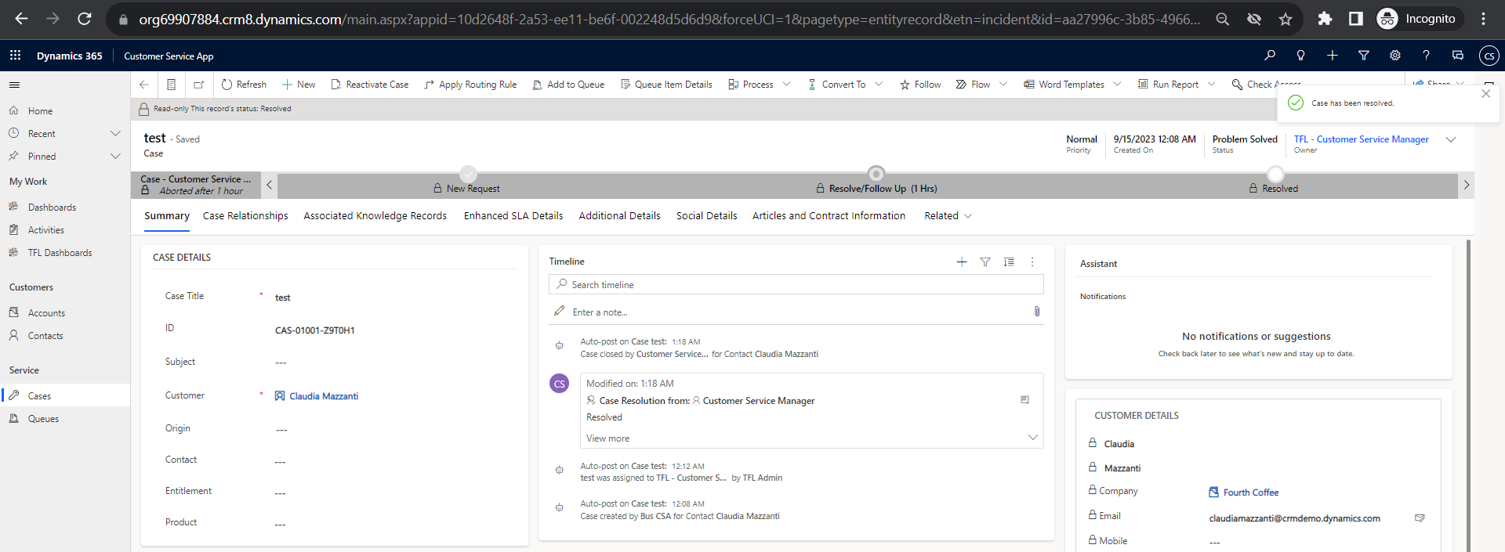

Create Follow up button should give pop-up

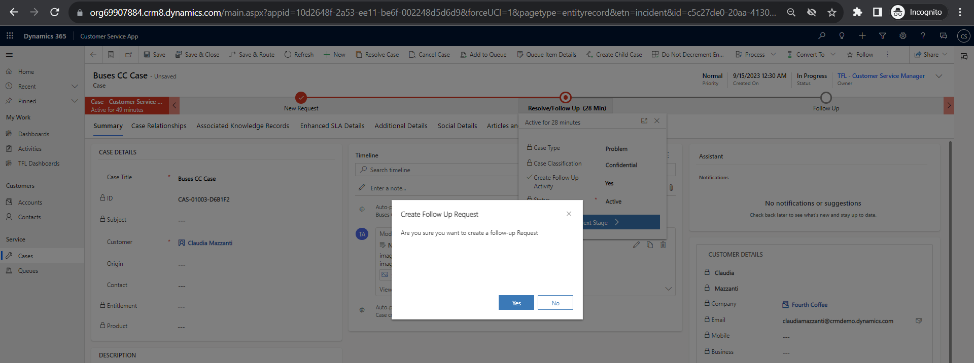

On click of yes follow up request to created to confidential team if case classification is confidential and notes to attached from case and contact(create follow up button will be locked)

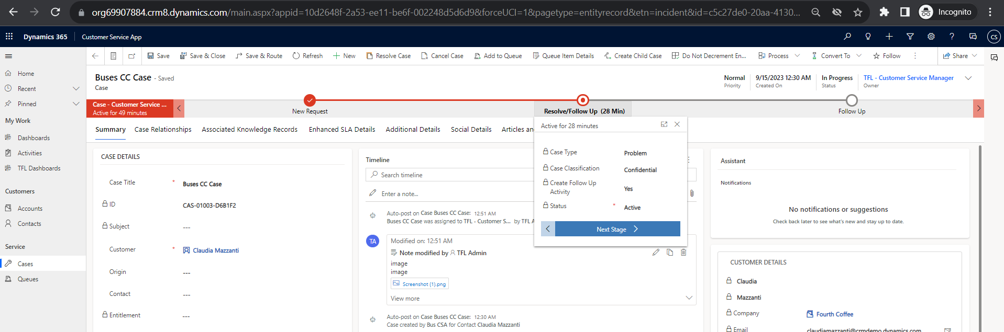

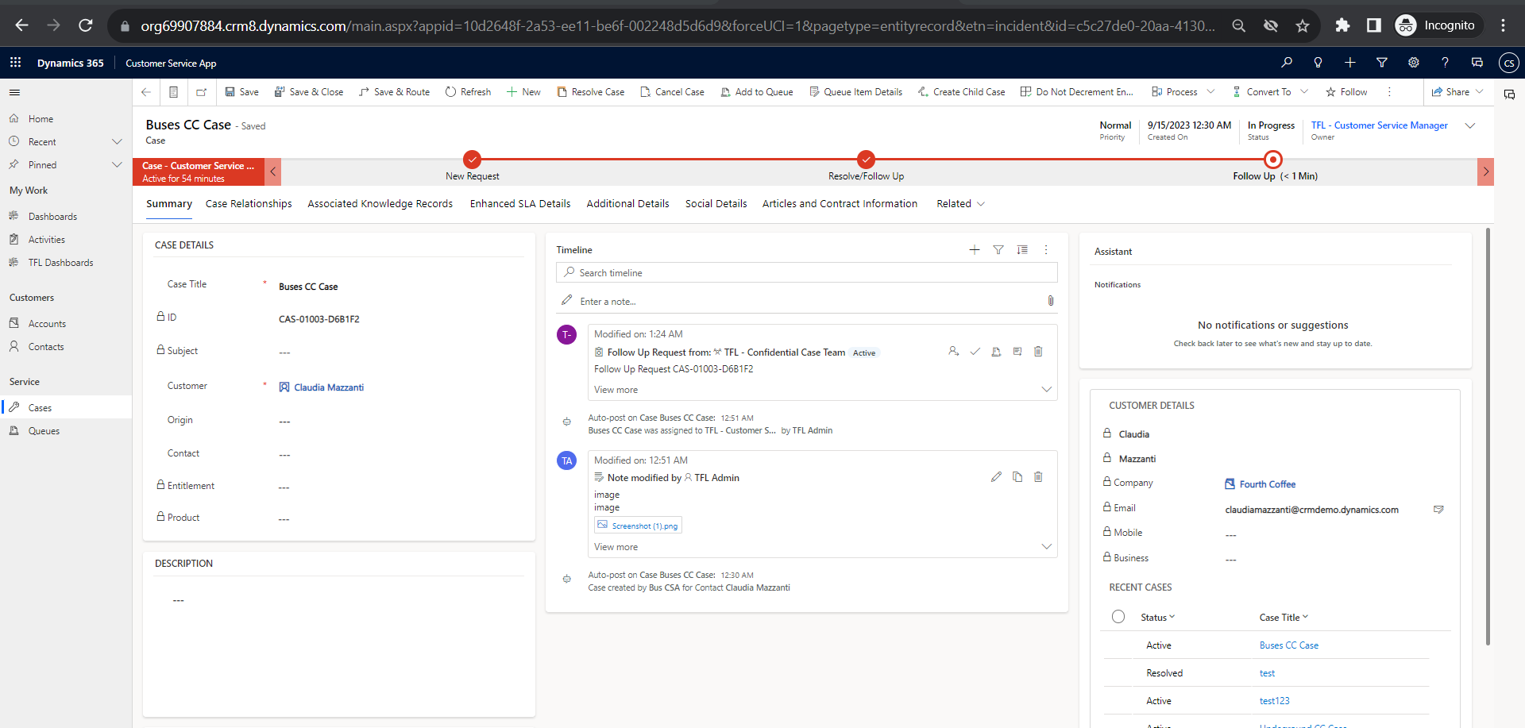

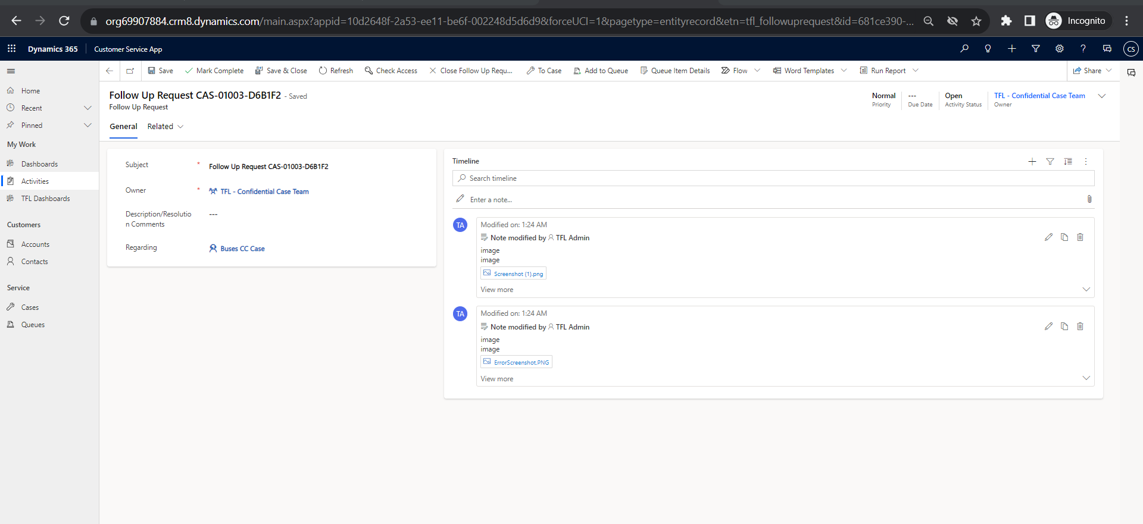

On click of yes follow up request to created to escalation team if case classification is normal and notes to attached from case and contact(create follow up button will be locked)

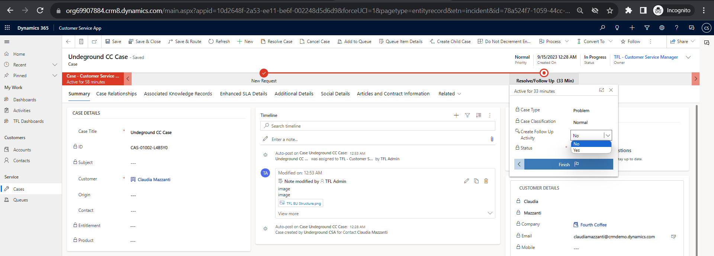

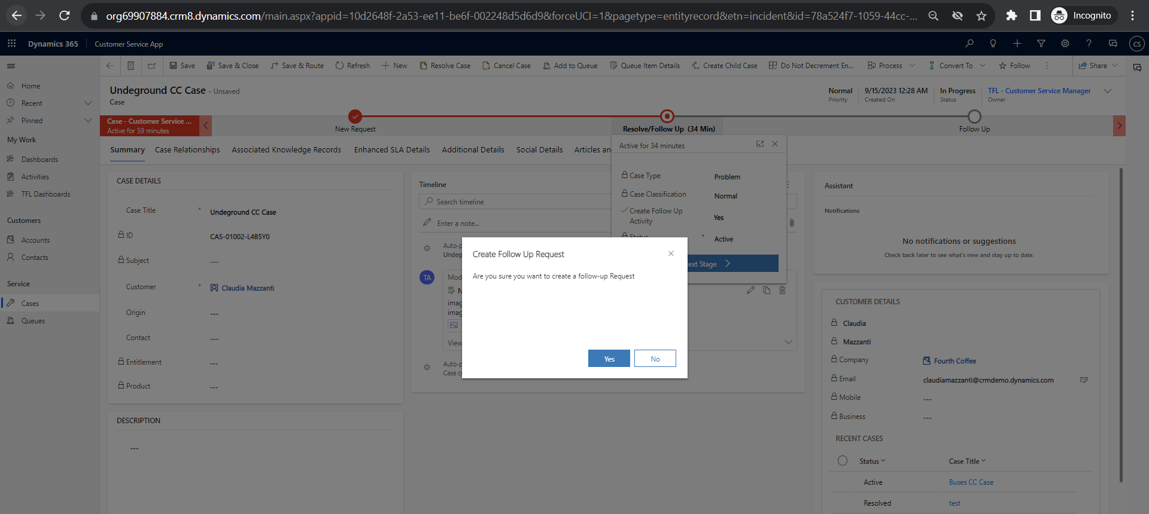

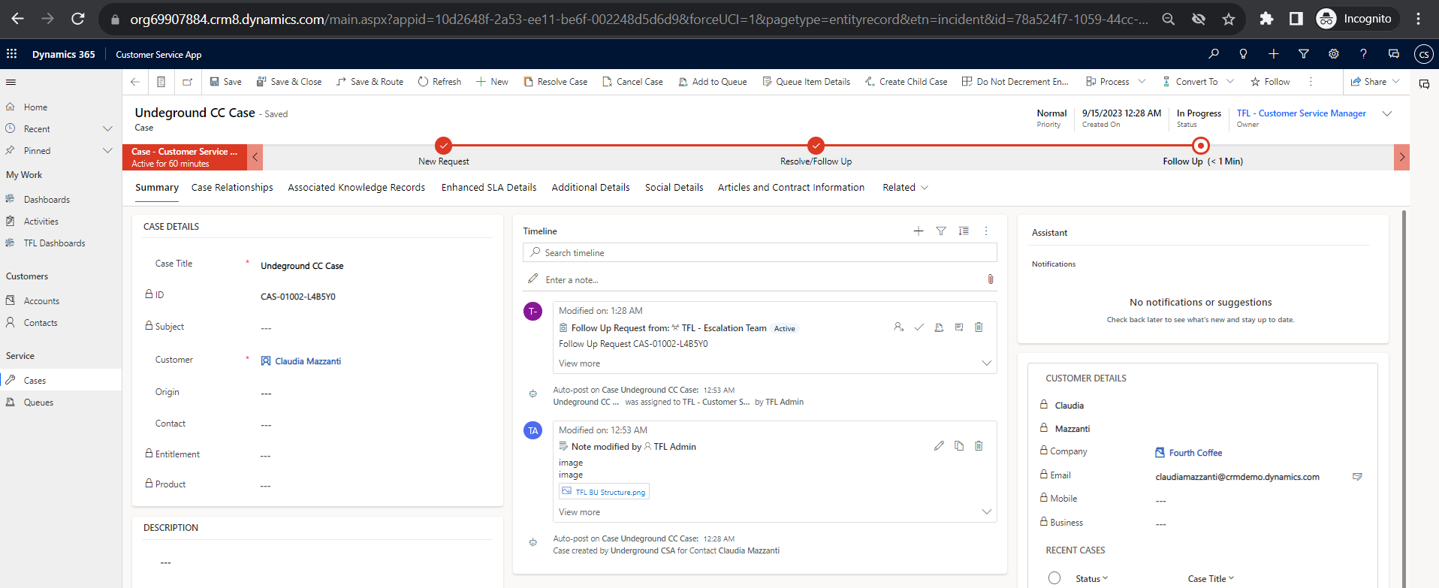

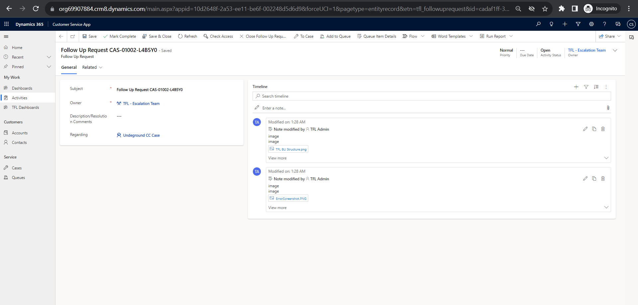

Case to automatically move to "Follow up" stage if follow up request is created and follow up date and follow up days to be shown in stage

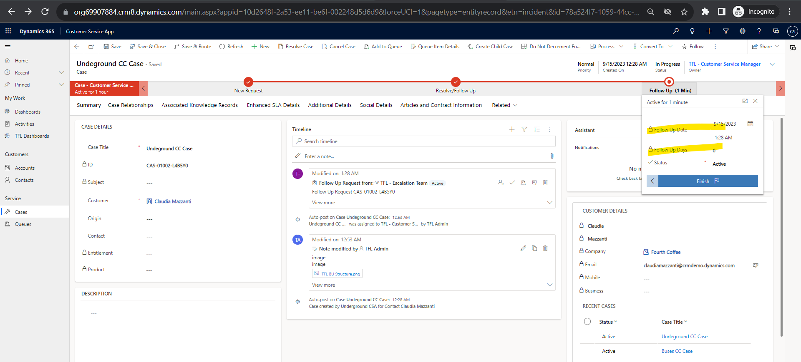

Post follow up completion, CSM resolving the case

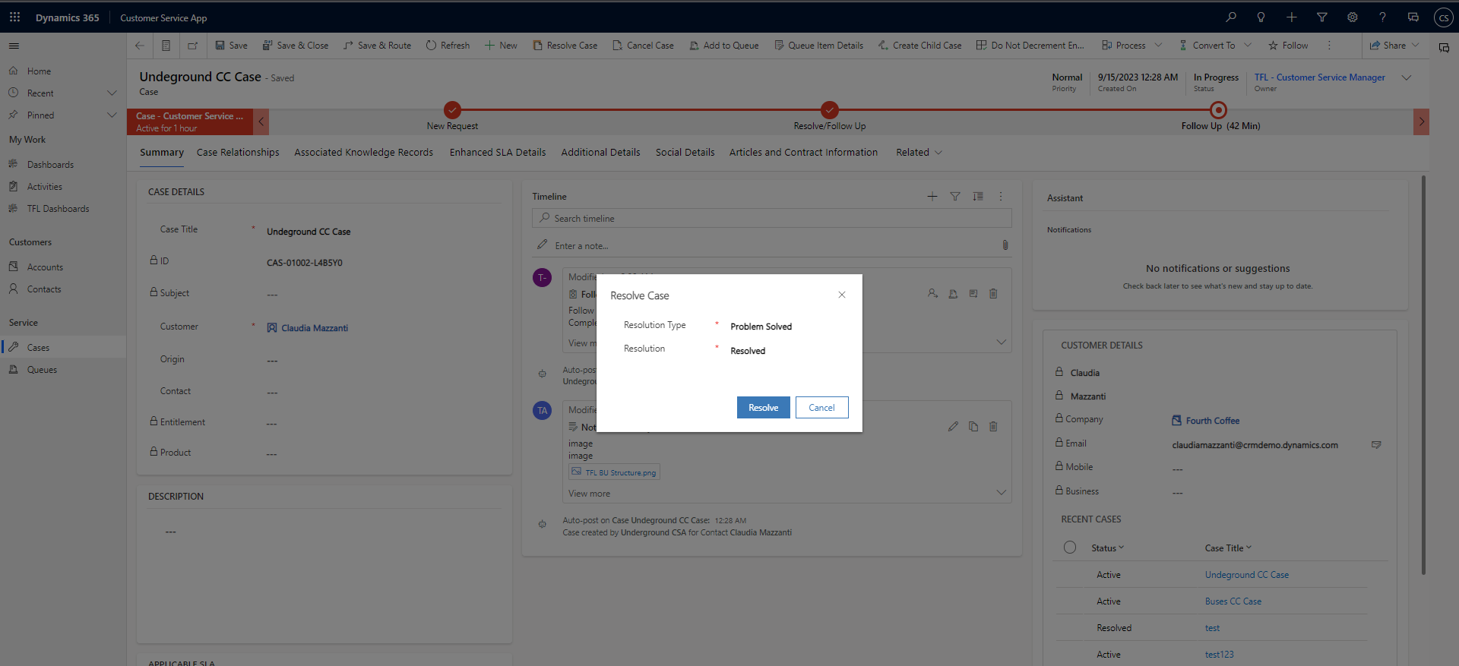

BPF stage moved to resolved after follow up

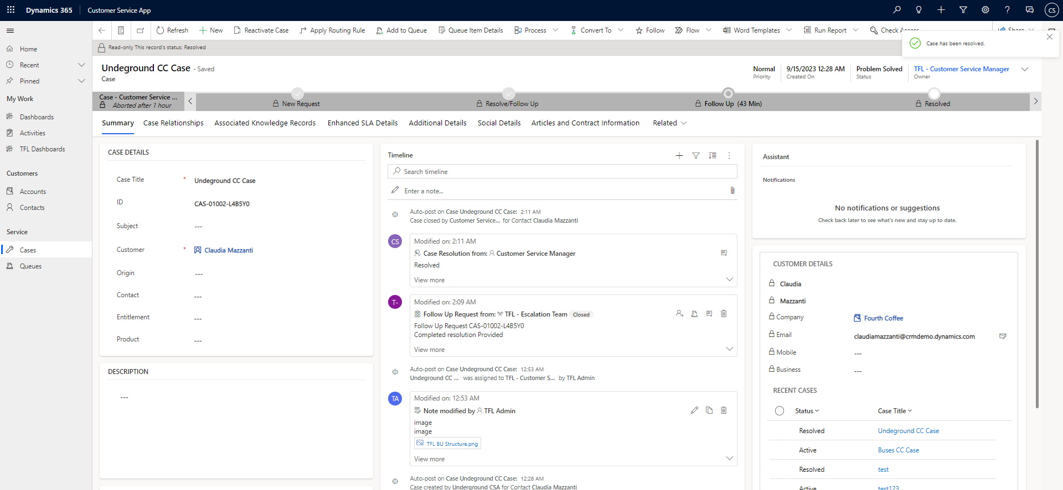

## TFL – Confidential Case Team

View Follow up requests assigned to the team in the dashboard

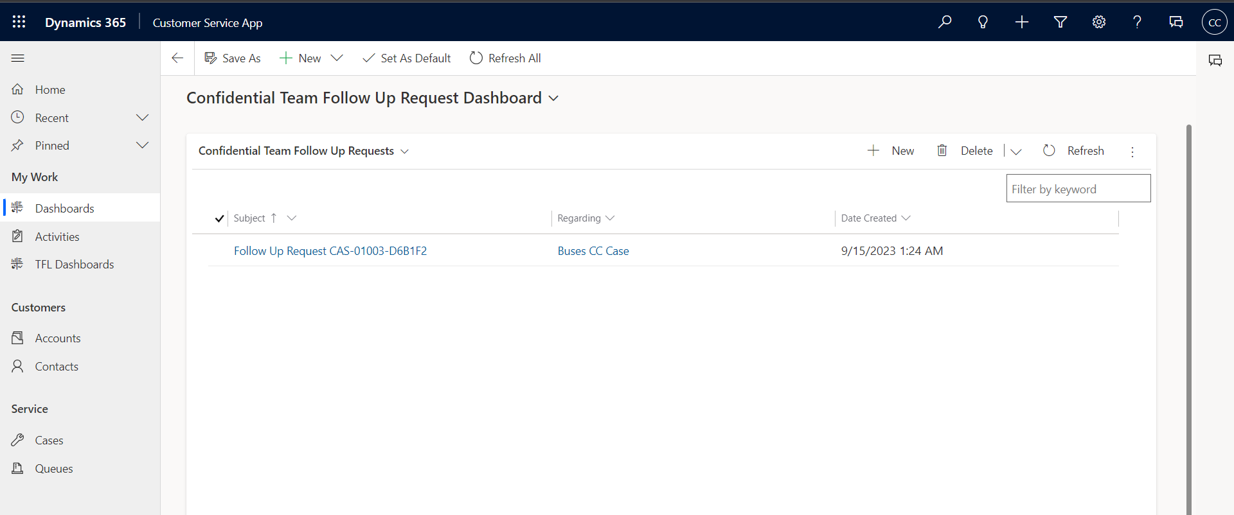

Should be able to see the attachments in the follow up requests

Should be able to provide additional info/comments or resolution comments

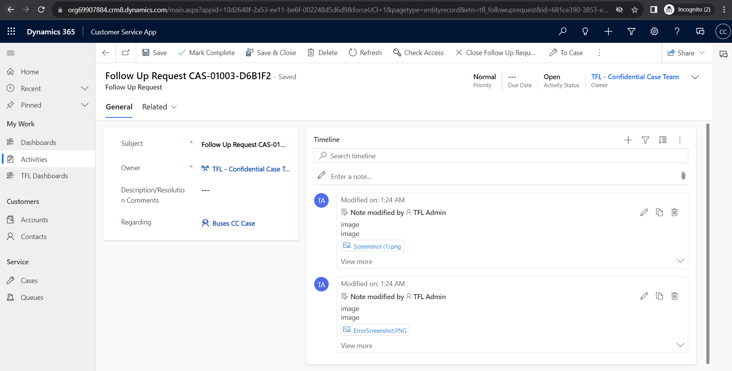

## TFL – Escalation Team

View Follow up requests assigned to the team in the dashboard  
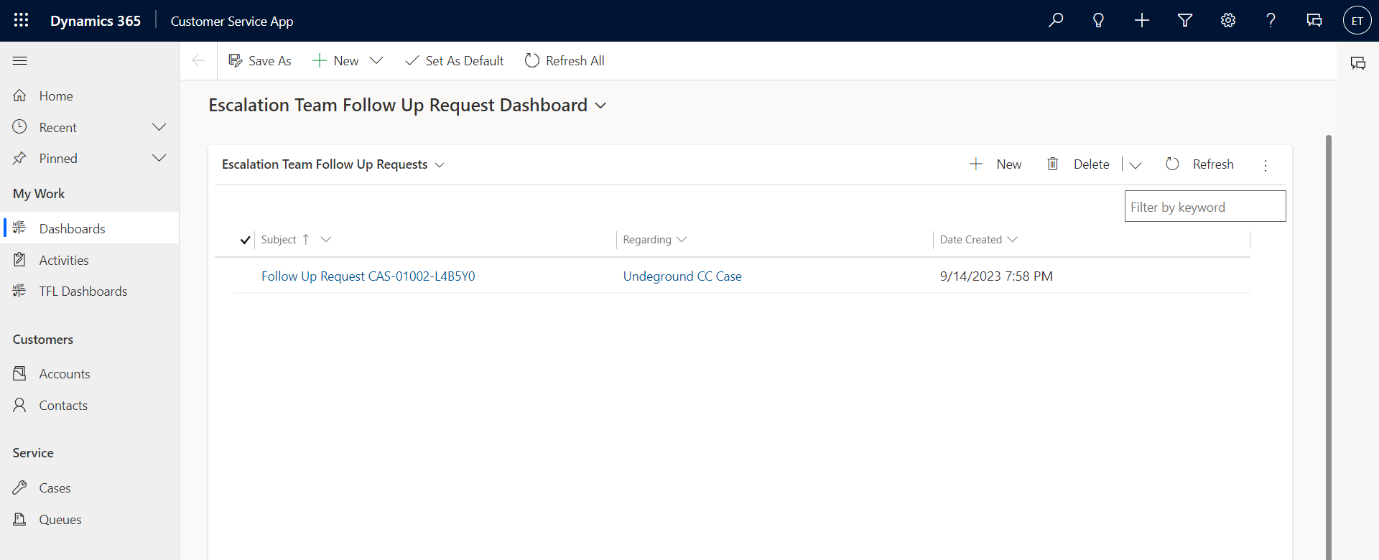

Should be able to see the attachments in the follow up request

Should be able to provide additional info/comments or resolution comments

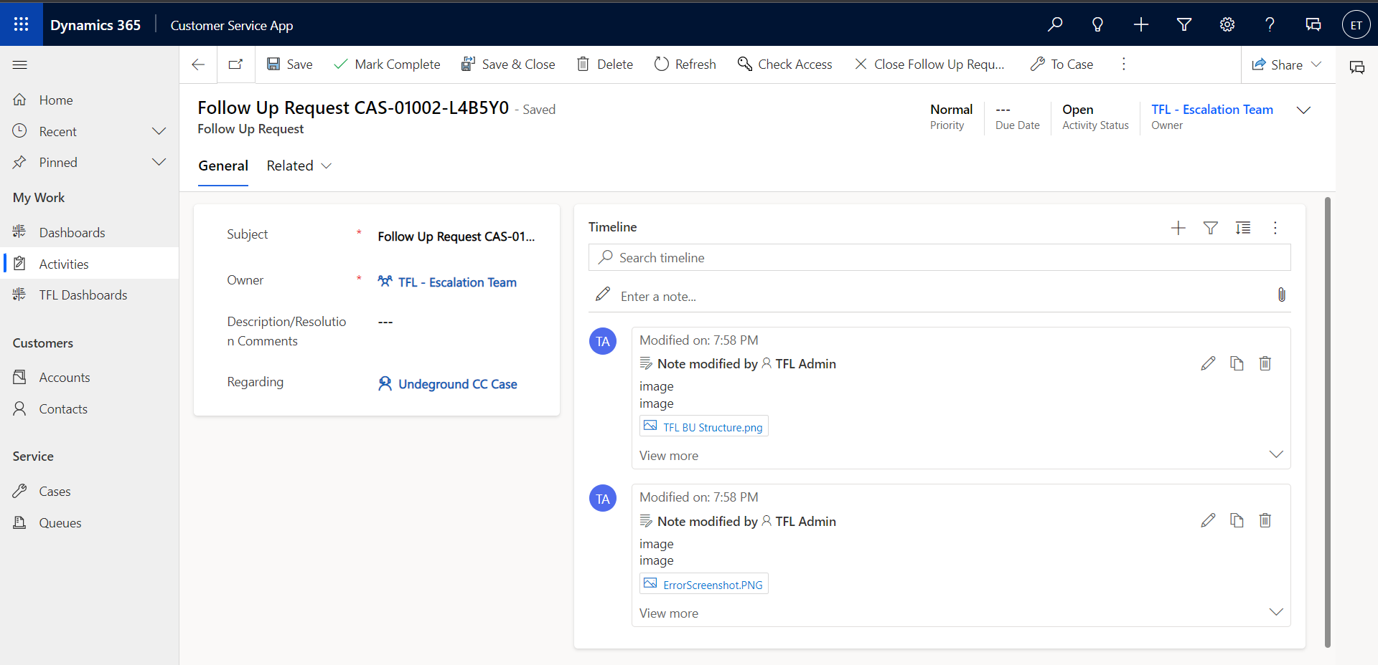

Post the Follow Up Request Task completion

